**Design Diagrams**

Name : Himadri Pal

Roll no. : 15IT119

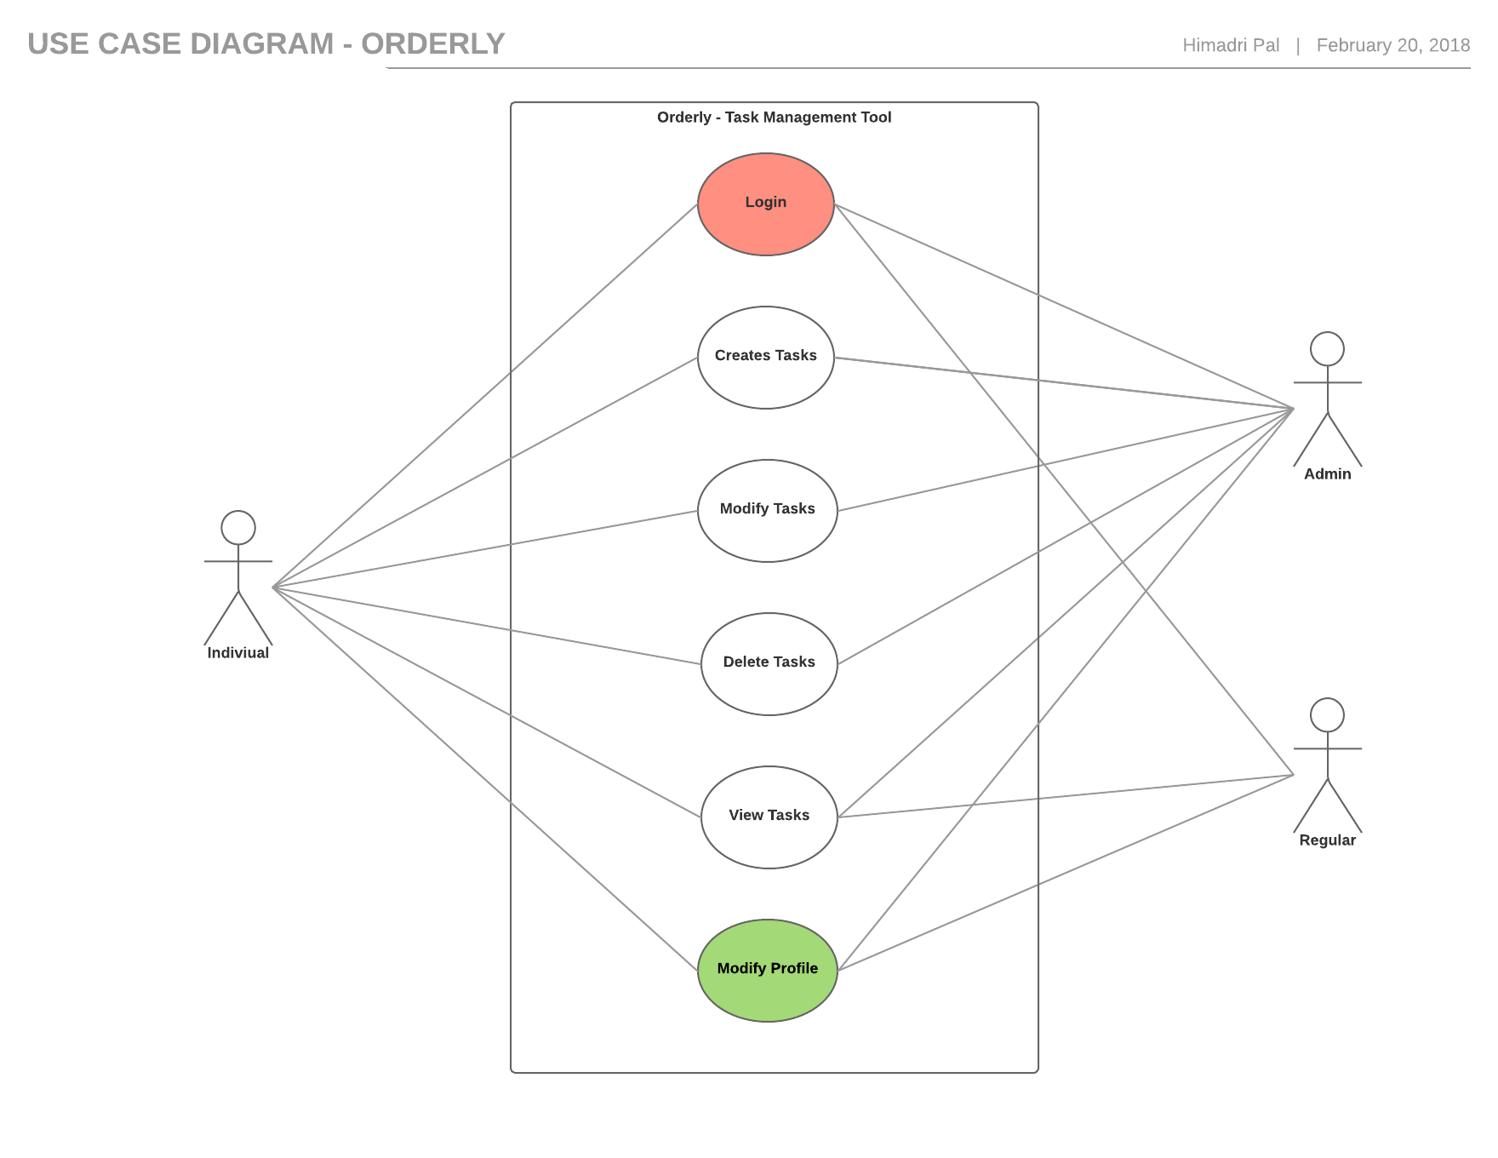

**Class Diagram**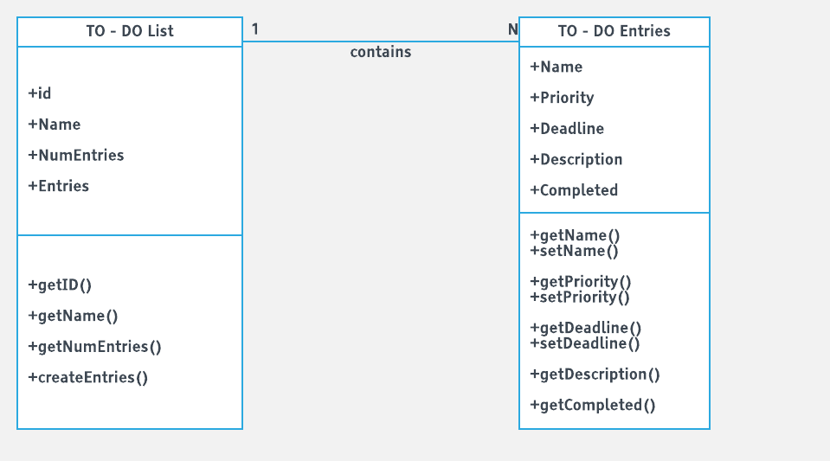

**ER Diagram**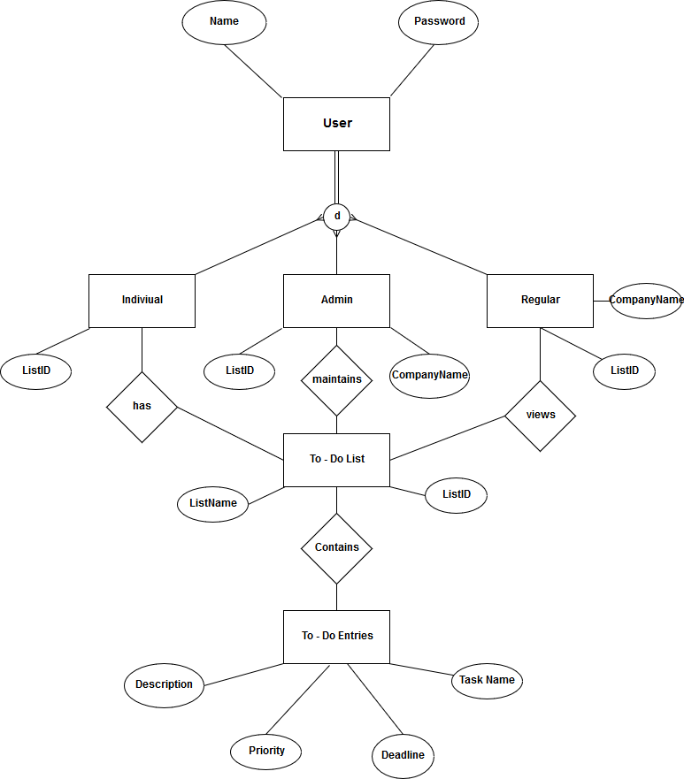

**Sequence Diagram**

**LOGIN :**

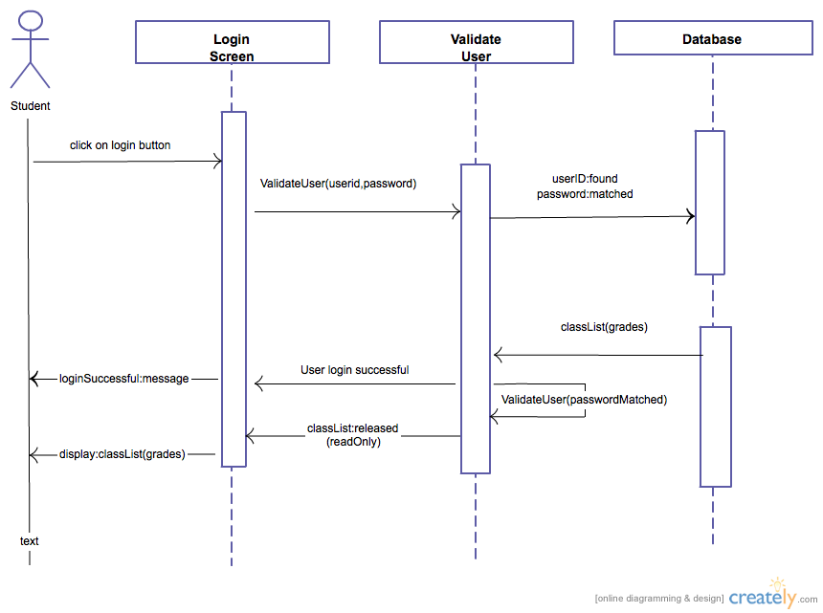

**TO Entries :**

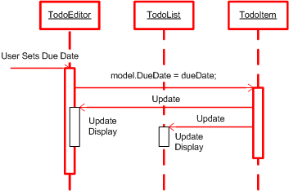

**Swimlane Activity Diagram :**

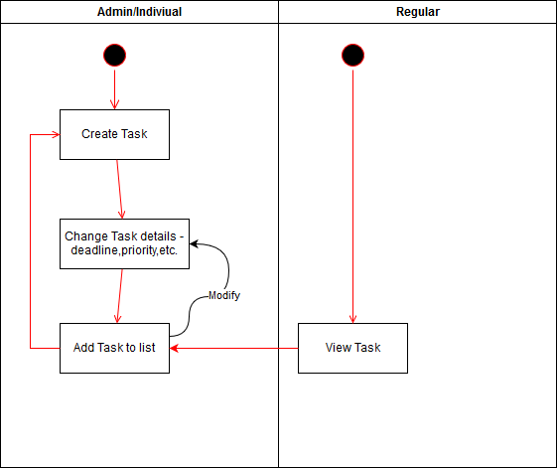

**Navigation Diagram :**

